A comparative review of different CNN models and their effectiveness with Image Recognition

Brendan Fitzpatrick
F8122818
TMA 01

Contents
Project Goals, Description, Scope and Impact 3
Definition 3
Scope 3
Account of Related Literature, including Review of Sources 4
Baseline ConvNet 4
ResNet 4
MobileNet 4
Resources, Planning, Risks and Lifecyle Review 6
Resources and Skills 7
Risks and Mitigations 7
Project Work Analysing and Solving a Practical Problem, demonstrating how your Computing and IT knowledge and skills have been extended 8
1. Data Preparation 8
2. Training 8
3. Evaluation 8
4. Comparison 8
5. Conclusion 8
LSEPI and EDI Concerns 9
Personal Development, Review and Reflection 10
Bibliography 11
Appendix 1 – Project Ethics Checklist 12
Appendix 2 – Project Log Extracts 13
Appendix 3 – Email Communication 14

Project Goals, Description, Scope and Impact

Definition
For this project I will be investigating different versions of CNN architectures and their effectiveness when used for image recognition, comparatively interpreting the metrics of each model.
Critically evaluating the pros and cons of each CNN model for image identification; using one dataset to ensure fairness sourced from Kaggle focused on mushroom species.
The result of this project is to produce a clear and defined review including graphs showing comparative findings in terms of computational efficiency predictive and accuracy performance when applied to image recognition under controlled conditions.

Scope
I will be including the following models for this project, baseline CNN, ResNet CNN, MobileNet CNN.
Using the above models for comparison purposes. I will be keeping the optimisation of these models to the minimum; thus, providing a controlled environment for experimentation and reporting purposes.
This will ensure my results and outcomes are not skewed during my evaluation.
This project will not be exposed to public interaction or real-world testing these are outside the scope; nor will the focus be on architectural innovation or extensive hyperparameter experimentation beyond what is required for the environment.

Account of Related Literature, including Review of Sources

For our project we need to study and identify several architectures to decide the most appropriate one for image recognition. In this literature review we will be reviewing the following architectures: Baseline ConvNet; ResNet; MobileNet

Baseline ConvNet
A CNN is a neural network that applies a small-scale filter across an image. These filters preserve the spatial structure of the image.
The same filter is reused to detect patterns, further improving the model’s representation and ability to identify aspects of the image including straight lines, and curves.
The filter allows for the level of abstraction to increase with each layer.
ConvNets have been shown to approach human-level performance in certain tasks and have become the dominant approach to recognition and detection. (LeCun et al., 2015)

ResNet
A key limitation of Deep Neural Networks is the vanishing gradient. The gradient that updates weights become smaller as it propagates backwards through the model thereby affecting deeper architectures.
ResNet creates a shortcut which allows the gradient to flow backwards reducing the impact of the vanishing gradient. This improves optimisation and works to mitigate degradation problems such as training errors which increase as the network deepens comparatively to shallower networks. (He et al., 2015)

MobileNet
The key area that MobileNet tackles is computational efficiency, unlike other CNNs that require a lot of computational power to run MobileNet does not.
A way in which this is achieved is through depth wise separable convolution.
How this works is instead of applying a 3 x 3 filter to all input channels at once it applies the filter to each channel separately. Then combining them using a 1 x 1 pointwise filter reducing computational cost. (Howard et al., 2017)
However, the accuracy of identification is reduced depending on parameter configuration. (Khasoggi et al., 2019)
This type of model is suitable for devices that have low computational abilities such as mobile phones and embedded systems including Raspberry Pis, all of which may struggle to run a full convolution model.
We are comparing the strengths and weaknesses of these 3 models through a base line to better understand and critically analyse the outcomes.
These models are designed for 3 specific aspects of a CNN architecture, the standard CNN that will portray the fundamentals as well as a grounding reference for comparison, a residual neural network which focuses on improving weighted training of CNNs and mobile net that focuses on computational efficiency.
This project will academically review the effectiveness of AI models with image recognition using influences including dataset imbalance, model speed and accuracy ability to predict outliers, using metrics such as Precision, latency and recall as some identifiers to conduct my investigations.
The goal is not to find which is the best model for image recognition, but rather which model would be most effective for its intended purpose, such as portability need for accuracy or efficiency requirements.

Resources, Planning, Risks and Lifecyle Review

The plan of this project is to implement a modified Machine Learning Engineering Lifecycle.
This lifecycle is appropriate for the purposes as it will show the steps for developing my AI models for experimental comparison.
The lifecycle will take the following steps:
- Problem Definition – we decide on the problem that needs to be tackled.
- Dataset Preparation – prepare the chosen dataset for training.
- Model Implementation – develop the models we plan to use for this project.
- Controlled Training - ensure that the optimisation of the models is kept to the minimum required.
- Evaluation using defined metrics – evaluate the results focusing on F1-Score, accuracy, precision etc.
- Comparative analysis – comparing the results of each model to one another.
- Reporting – report my findings using graphs plots and other evaluation methods and visuals.
This is summarised in figure 1
These steps show a clear outline of the lifecycle I plan to use. The visual can be seen in Figure 1 ML Engineering Lifecycle.
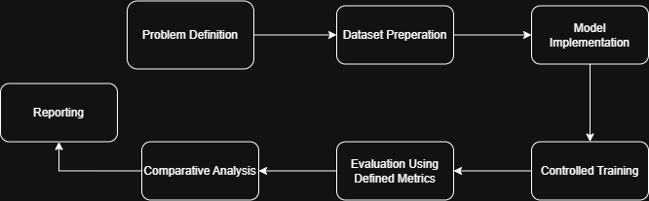
Figure 1 ML Engineering Lifecycle
This lifecycle is subject to change depending on evaluation results from this project.

A project timeline has been created based off the lifecycle for this module which can be seen in Figure 2.
Figure 2 Gantt Chart

Resources and Skills
For this project I have sufficient computational resources available allowing for efficient CNN training via GPU acceleration.
With my foundation of knowledge from TM358, I intend to build upon this using Keras as my ML framework, utilising different analytical tools from past TMAs such as ROC graphs and scatter plots to critically analyse and compare each model.

Risks and Mitigations
Some risks that may occur during this project include overfitting of models, time constraints and data imbalances.
These issues can be mitigated through data refinement methods such as augmentation, cleaning and normalization.
The risks and mitigations can be seen in Figure 3
Risk | Level | Mitigation
Time Constraints | High | Careful and clear planning using the Gantt Chart to help maintain the scope of the project ensuring everything is achievable within the available timeframe
Data Imbalances | Medium | Use different data techniques including Augmentation, Cleaning and balancing to reduce the impact of data imbalance within the dataest.
Model Overfitting | High | Incorporate techniques such as dataset validation and regularisation methods, monitoring the validation loss to track and reduce overfitting during training.
Computational Limitations | Medium | Where available ensure GPU Acceleration is used keeping both the dataset size and model complexity within constraints appropriate for the hardware resources.
Figure 3: Risks and Mitigation Table

Project Work Analysing and Solving a Practical Problem, demonstrating how your Computing and IT knowledge and skills have been extended

In real world applications of AI image recognition selecting the appropriate architecture can pose a challenge, as every metric needs to be considered and balanced to meet the required constraints. My project aims to address this issue by conducting experimental comparisons between three CNN architectures critically analysing the outputs across a set of defined criteria.
This experiment will be run under controlled and consistent conditions using identical data splits and a standardised evaluation of the metrics. Using a baseline CNN as reference to ensure that hyperparameter tuning is kept to a minimum allowing for consistent training across the board.
All of which provides a fair and equal experiment which can observe primarily the performance of each model instead of the effects of external variables.
This project will take the following steps:

Data Preparation
The dataset will be reviewed and cleaned ensuring that it contains relevant information it will then be split equally and efficiently to ensure that it doesn’t impact the model’s ability to train. Further augmentation of the data or normalization will also be conducted if required.

Training
The models will be trained using the prepared dataset hyperparameters will be tuned and adjusted minimally to ensure that the models are equivalent and provide equal output in this stage of my project.

Evaluation
This is where I will begin to review and evaluate the metrics of each model separately, implementing ROC graphs scatterplot graphs and other forms of evaluation to aid my review.

Comparison
Comparing the results of the metrics between models. Reviewing the outputs of the models including speed, accuracy, precision, recall, latency as well as other visual representations to assess both prediction performance and computational efficiency.

Conclusion
Finally, I will be reporting on the results findings and concluding the outcome for my experiments and project.
Expanding on the knowledge I gained during TM358 in which I developed baseline CNN for image recognition. I intend to further my knowledge by incorporating ResNet and MobileNet architecture. This will allow for a deeper comparison and investigation whilst also exploring the options of mobile deployment for demonstrative showcasing.

LSEPI and EDI Concerns

There are several Legal, Social, Ethical and Professional Issues that this project raises, as well as Equality, Diversity and Inclusion considerations.

This project will be using datasets sourced from Kaggle, is a free publicly available website containing datasets of all shapes and sizes.
The data will be used academically and in accordance with licensing and legal conditions. There are no data protection concerns due to the absence of personal data.

Some data biases and fairness issues to take into consideration include the potential for class imbalances where there may be an abundance of one class of images over another, which risks the model favouring majority classes that can skew the output results of each model.
To ensure fairness the dataset will be cleaned and split if needed as well as augmented or normalised where required.
An unequal class representation may lead to performance issues across the models impacting the outcomes of the evaluation.
An EDI concerns arise if the model begins to show bias; this may imply there is an imbalance within the dataset which might distort evaluation metrics.
Tackling this will require going beyond accuracy as a metric to include aspects of the model such as precision, recall, F1-score. These provide a more balanced evaluation to the experiment ensuring transparent reporting improving legitimacy.
From an ethical perspective, AI image recognition models can misclassify images into the wrong groups; this is known as a false positive or false negative. This means that caution would need to be taken if this was to be deployed in real-world scenarios, especially as my project can lead to safety issues by identifying a mushroom as the wrong species.
What has been taken into consideration specifically is that this project is solely an academic piece rather than a diagnostic one.

To keep in line with academic integrity, all literature reviewed and referenced will be done in the Harvard citation style, there will be no copying except for when adding a section into my reports and then referencing it. Models will be developed independently using Keras and all results of this project will be reproducible.
The results will be reported without manipulation and with full transparency.

Personal Development, Review and Reflection

I chose the ML Lifecycle because it is the lifecycle that suited my project progression most although I did have to adjust it by removing certain steps that are not going to be included in my project.
I found that in the process of breaking the whole project down into steps this improved clarity of what I was aiming to achieve, giving me a more manageable scope allowed me to plan the project more efficiently, this also helped me reduce the risk of scope creep keeping my goals in line and realistic.
By breaking down the structured phases, helped to provide clear and concise steps that will be taken.
This has all been organised and time allocated within a Gantt Chart.
Building on my knowledge gained from TM358 I investigated and worked towards building up my knowledge of ResNet and MobileNet architecture, improving my understanding of the vanishing gradient and learning about depth wise convolution which is used for MobileNet CNNs.
Having investigated a couple of papers I was also able to extract relevant information and concepts I plan to implement during this project.

To ensure that my comparison provides the outcomes that I am expecting I will focus on refining the model to the point fairness is the focus, this will be achieved by controlling the hyperparameters tuning of each model.
Ensuring the dataset is cleaned and varied to reduce the risk of bias and class imbalance through the training.
I worked to improve my academic writing and explanations by adjusting my wording to be more precise and fixing grammatical errors and reducing fragmentation in my writing.

I will develop and use diagrams to show my ideas and roadmap as well as visual metrics such as graphs and ROC curves to substantiate my findings throughout this project from the training and comparison to the review and outcome.
Providing visual representations of different aspects of my project including Lifecycles, graphs and wireframes, will add depth to my project and improve understanding of my aims and goals
Further ensuring that I provide my results in clear and concise ways with complex ideas being broken down into more accessible language,

I have found that so far this project has helped me improve my confidence in my ability to conduct and complete this project as well as improving my understanding of the architectures of the different models I plan to use as well as the potential trade-offs that will need to occur to make things fair and provide a desirable result.

Evidence of ongoing planning and reflection is documented in the project log extract provided in Appendix 2.
Word Count (1976/2000)

Bibliography

LeCun, Y., Bengio, Y. and Hinton, G. (2015) “Deep learning,” Nature, vol. 521, no. 7553, pp. 436–444 [Online]. DOI: 10.1038/nature14539 (Accessed 2 March 2026).
Howard, A. G., Zhu, M., Chen, B., Kalenichenko, D., Wang, W., Weyand, T., Andreetto, M. and Adam, H. (2017) MobileNets: Efficient Convolutional Neural Networks for Mobile Vision Applications [Online]. Available at https://arxiv.org/abs/1704.04861.
Khasoggi, B., Ermatita, E. and Samsuryadi, S. (2019) “Efficient mobilenet architecture as image recognition on mobile and embedded devices,” Indonesian Journal of Electrical Engineering and Computer Science, vol. 16, no. 1, p. 389 [Online]. DOI: 10.11591/ijeecs.v16.i1.pp389-394 (Accessed 3 March 2026).
He, K., Zhang, X., Ren, S. and Sun, J. (2015) Deep Residual Learning for Image Recognition [Online]. Available at https://arxiv.org/abs/1512.03385.
(Accessed 3 March 2026).

Appendix 1 – Project Ethics Checklist

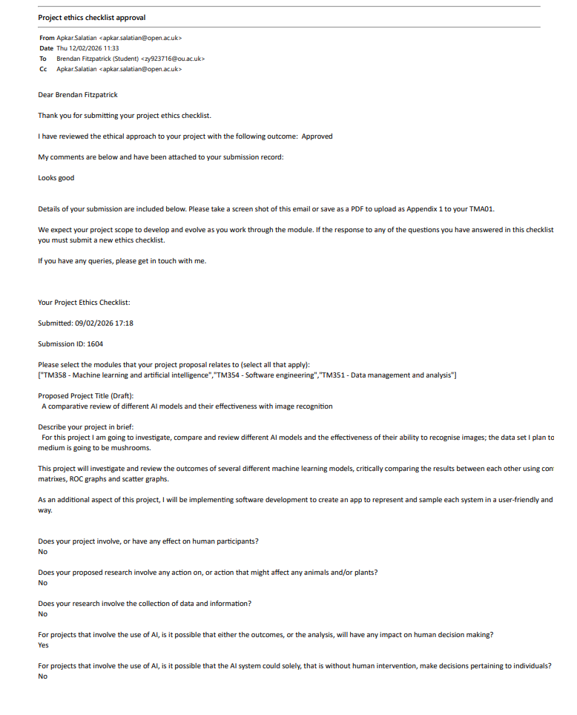

Appendix 2 – Project Log Extracts

Entry 1 – Project Topic Selection
During the early stages of this project, I explored several ideas before finally focusing on comparing different CNN architectures and their effectiveness for image recognition. This was later refined further after discussing it with my tutor focusing on the following, Baseline CNN, ResNet and MobileNet models.
This is going to ensure that the project is kept achievable and meaningful.

Entry 2 - Dataset and Experimental Focus
Once the project focus was decided upon, I began to investigate potential datasets and what would be the most effective and suitable for image and classification tasks. I selected a publicly available mushroom dataset provided from Kaggle as it provides a manageable size for this controlled experimentation.
During this time, I began to outline the criteria of what will be used to compare the models including accuracy, precision recall and computation efficiency.

Entry 3 – Literature Review
I began a reviewing several key papers and documentation that are focused on Convolution neural networks, residual networks and MobileNet architectures. I then further updated my project Title to better reflect the nature of this study. During this time, I identified several ethical and practical consideration which included the potential dataset bias, class imbalance and the risk of misclassification when applied to real-world scenarios.

Entry 4 - Project Planning and Model Selection
To support the organisation and progress of my project, I created couple accompanying images and graphs including a project lifecycle and Gantt Chart which included literature reviews, dataset preparation, model implementation and evaluation.
I finalised on the architectures that will be implemented during this project, choosing Baseline CNN, ResNet and MobileNet to allow for a comparison between Standard, deep residual and computational efficient network designs.

Appendix 3 – Email Communication

Meeting / Discussion 1 – Project Confirmation
Date: 06 February 2026
During my initial meeting with my tutor, we outlined several potential ideas and routes that my project could take before refining it and deciding on a comparative investigation of CNN architecture.
We discussed the use of datasets and the risks that might occur as well as the potential of reduced complexity that might impact my overall project integrity.
Meeting Summary:
Title of you project can be something like 'A comparison of ML techniques to identify stars/mushroom (or something else) images'
You will get a dataset set of stars or mushrooms (or maybe something else) from Kaggle to train a set of ML algorithms (possibly CNN, random forest, k-nearest neighbour, SVM, naive bayes etc - perhaps the ones you choose are determined by what other people have done i.e. a literature review).
You will train the datasets using your chosen ML algorithms then apply it to another set of data to determine if they make the correct identifications.
I suggest you test your algorithms after training on a large data set (maybe 500) to determine how accurate each are - you can then present you findings in many ways e.g. ROC graph, confusion matrix etc and determine which is the best.
You will create an app where you upload a data item, and it will generate the results of each algorithm - this will allow you to present sample outputs of your system in the EMA. Given it is an app you can also include software engineering aspects to your project i.e. list functional and non-functional requirements in your reports

Meeting /Discussion 2 – Project Progression
Date: 20/02/2026
During this meeting we discussed any additional aspects that might be needed in my project what I could focus on and how I could improve my overall assignment

Meeting Summary:
This is a summary of the meeting today which hasn't been covered in my last email:
- Need a data flow architecture which show the transformation of kaggle i.e clean, train, identify - show this in diagram form
- Need architecture for mobile app - could be MVC (model view controller) - show this daigram form
- Need wireframes for mobile app design
- Need discussion of your 3 CNN algorithms (ideally based on a literature review)
- Need to refer to your previous OU course and what knowledge you will extend
- Need a Gannt chart
- Need list of functional and non-functional requirements
- Perhaps need a use case diagram
- Need to state testing strategies (forgot to mention this in meeting)

